Chapter 16, Solution 46.

Determine i_{o}(t) in the circuit in Fig. 16.69.

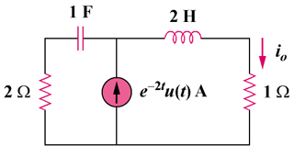

Figure 16.69
For Prob. 16.46.

Solution

Consider the following circuit.

2s

2

1

1/s

1/(s + 2)

V_{o}

I_{o}

Applying KCL at node o,

,

